

SHREEJI GROCERY
Shreeji Grocery is an online store that sells a variety of item and Fruit, Vegetables , Dryfood directly to customers.

Project Partners:
MR. KRISH SAVALIYA, B.SC.IT-5TH MR. RUTVIK SORATHIYA, B.SC.IT-5TH
:: submitted to :: BKNM University, Junagadh

:: GUIDED BY ::
Mr. Ripal V. Pandya
Mr. Milind D. Anandpara

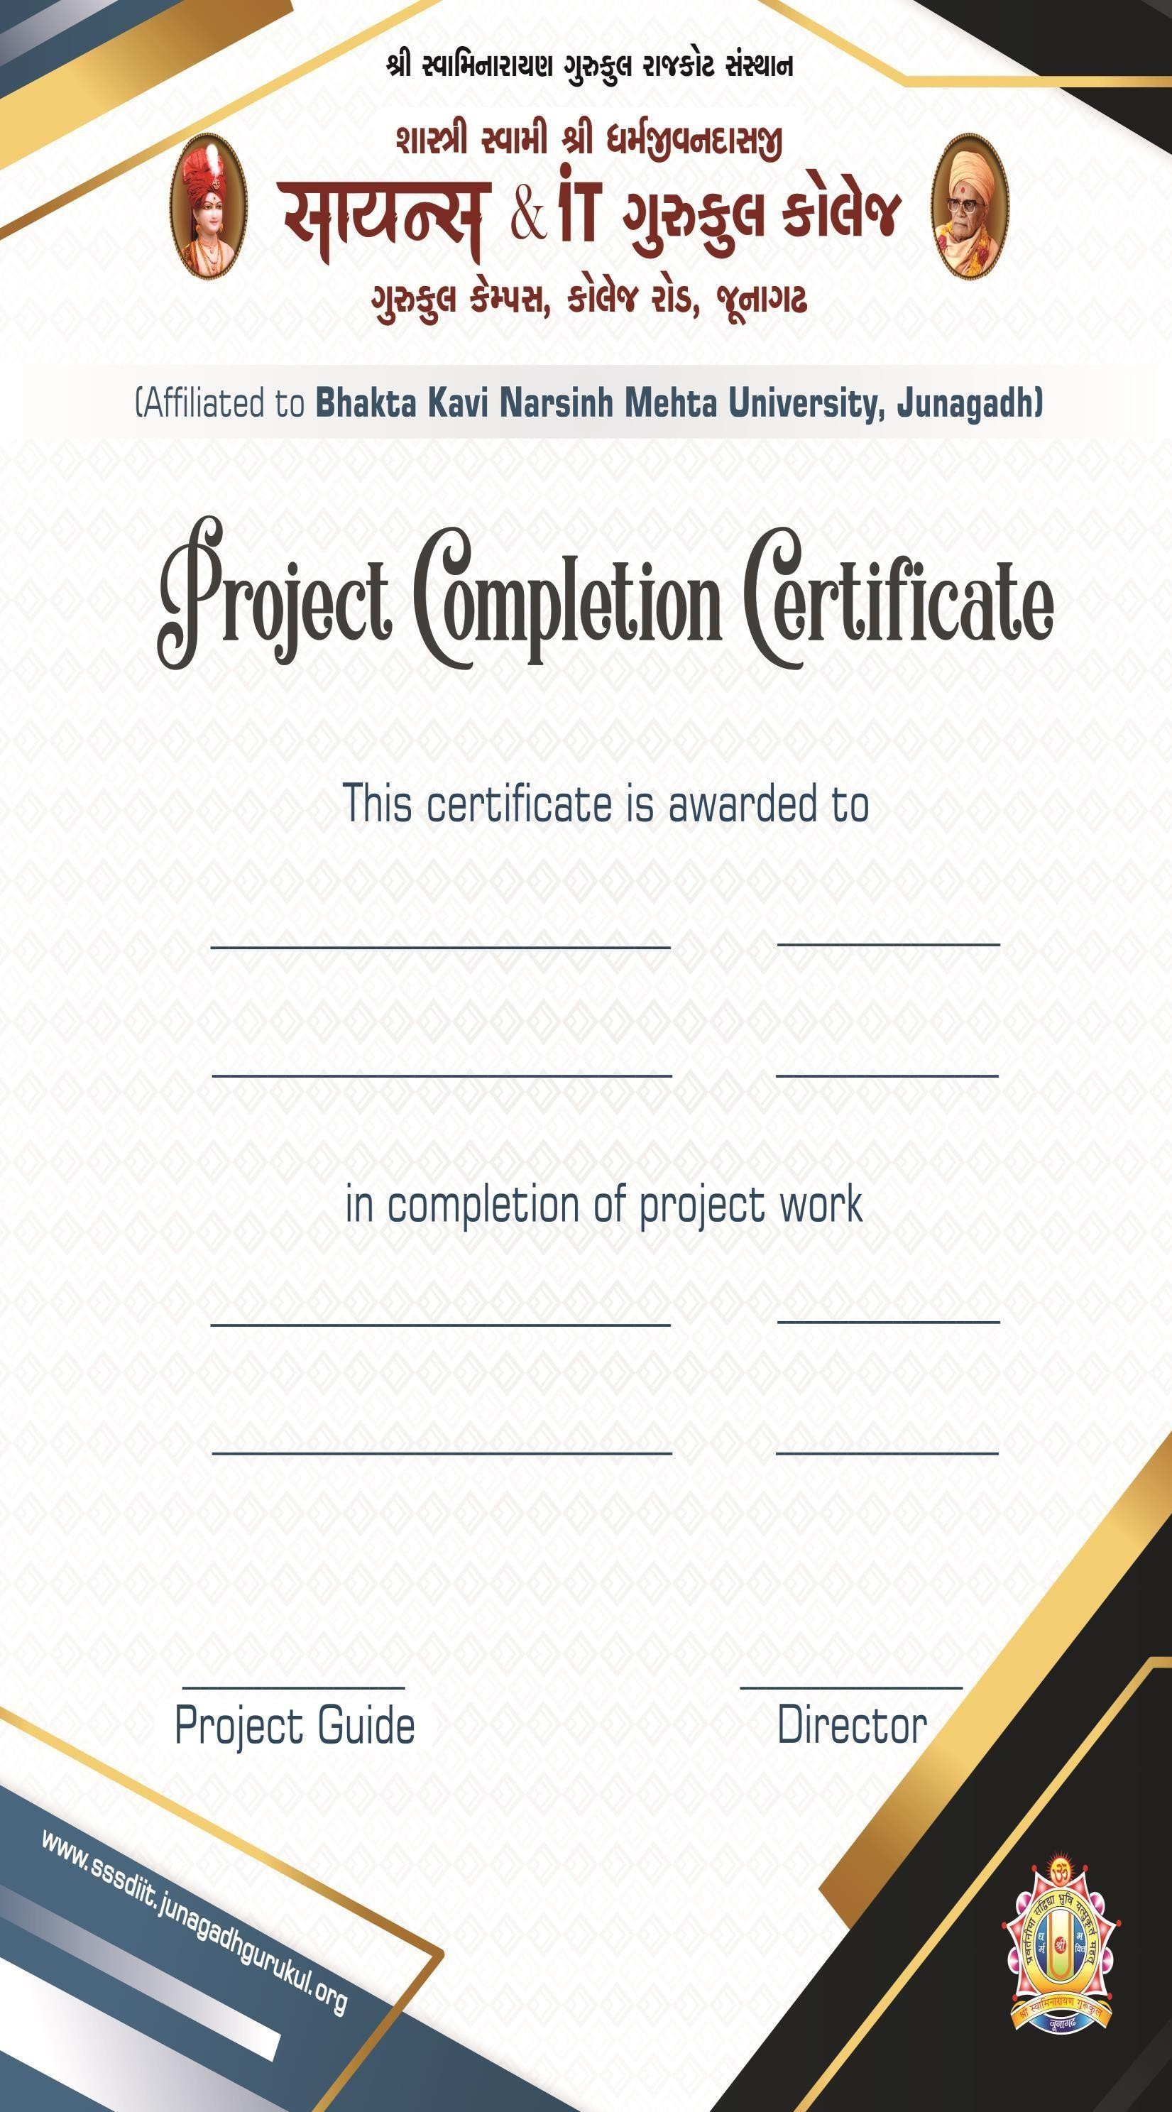

Mr. Krish Savaliya B.SC.I.T-2025

Mr. Rutvik Sorathiya B.SC.I.T-2025

PHP 01/07/2025

MySQL 08/09/2025

Mr. RIPAL V. PANDYA

A

PROJECT REPORT ON

SHREEJI GROCERY
Submitted in Fulfillment of Requirements For Completion of Semester - 5 in Bachelor of Science in Information Technology
Year 2025
To

SHASHTRI SWAMI SHREE DHARMAJIVANDASJIINSTITUTE OF INFORMATION TECHNOLOGY
JUNAGADH

Guided By: Prepared By:

Mr. Ripal V. Pandya Mr. Krish Savaliya

Mr. Milind D. Anandpara Mr. Rutvik Sorathiya

PREFACE

The web-enabled system has two different modules. They are as under.

Client-side

- Admin side
Each of the two modules has its own functionality. In the client side section user can join Site. This system provides central login facility. User can create his/her profile. In admin side module administrator are the user who manages the whole system and all users of this website. She/he has the database control.

Here our website name is SHREEJI GROCERY. The User Can see the category of syllabus from our web site. At the time of visiting our site we can see all categories with good resolution.

The customers fill user name and password then he/she login in our site see the category of syllabus. By this way it saves the lots of time of the user

ACKNOWLEDGEMENT

We are very thankful to all whose have helped in preparing this project. We are feeling a great happiness to present this website project. First of all we would like to thank “BKNM University” who give me an opportunity to give a chance to prepare a project.
Before we get in to thick of the things we would to add a few heartfelt words for the people who were part of this project numerous ways, people who give unending support right from the stage project ideas was conceived. In particular we would like to thank Mr. Ripal V. Pandya, Mr. Milind D. Andapara who has always inspired us and has directed us towards the successful completion of our project. They have been the guided through the project and their encouragement has left me indebted to them.
We are very thankful to the Director Sadhu RushikeshdashjiSwami and the Asst. Director Mr. Rajesh Bharad of Shastri Swami Shree Dharmajivandasji Institute of Information Technology – Junagadh.
We are also thankful to our classmate and few other people who helped us directly or indirectly in solving problem and in making our web development project more efficient and attractive.

Thank you…

Date: 11/10/2025 Mr. Krish Savaliya

Place: Junagadh Mr. Rutvik Sorathiya

INDEX

NO | Particulars | Page No
1 | Project Profile | 1
2 | Use of System Development Life Cycle Model | 2
3 | Feasibility Study | 5
4 | Requirement Gathering | 8
 | Requirement Analysis  - Hardware and Software Requirement  - Front - End Tools  - Back - End Tools  - Other Tools & Technology Used | 9
5 | Project Abstracts (User Roles & Capabilities) | 11
6 | Proposed System | 12
7 | Advantages & Limitations of Proposed System | 13
8 | Evaluative Report Using Pert Chart and Gantt Chart | 14
9 | Data Flow Diagram  - Context level  - 1st Level  - 2nd Level | 18
10 | Use Case Diagram | 23
11 | Flow Chart | 25
12 | Cost Estimation | 27
13 | Data Dictionary | 28
14 | Screen Layouts | 31
15 | Special Utilities | 38
16 | Testing | 39
17 | Implementation | 45
18 | Bibliography | 46

PROJECT PROFILE

Project Title | SHREEJI GROCERY
Project Description | This is Shreeji Grocery website. The user can see category of Grocery from our website. At the time of visiting our site we can see all categories with good resolution.
Front End | PHP
Back End | MySQL
Other Tools | Sublime Text Editor
Guide | Mr. Ripal V. Pandya, Mr. Milind D. Anandpara
Submitted To | S.S.S.D.I.I.T College

USE OF SYSTEM DEVELOPMENT LIFE CYCLE MODEL
- System Development Life Cycle is process of development of software. There are some steps to follow to create a system.
- In SDLC steps follows requirement gathering. In Requirement gathering questionnaire, personal interview etc. These are method for gathering information. Analysis phase includes creating software requirement
specification and analyses the gathered data. In design phase, design of software application i.e. database design and GUI design have to be prepared. In coding phase, coding is done different modules and forms. In testing phase, the different type of testing is done like integration testing, unit testing, system testing and at last the created website is implemented and maintained
- Following are the different Life Cycle Model example.

  - Waterfall model.
  - Iterative model.
  - Prototype model
  - Evolutionary model
  - Spiral model
  - R.A.D. model (Rapid Application Development)
- I am following waterfall model following is diagrammatic representation of different phase of waterfall model.

WATERFALL MODEL :-

- Requirement Gathering and Analysis :- All possible requirements of the system to be developed are captured in this phase and documented in a requirement in a requirement specific doc.
- System Design :- The requirement specification from first phase is studied this phase is studied in this phase and system design in prepared, system Design helps in defining overall system architecture.
- Implementation :- With inputs from system design the system is system is first developed in small programs called nits which are integrated in the next phase, each unit is developed and tested for its functionality which is referred to as unit testing.
- Integration and Testing :- All the units develop in the Implementation phase are integrated into a system after testing of each unit post integration the entire system is tested for any faults and failures.
- Deployment of system :- Once the functional and non-functional testing is done the product is developing the customer environment or released into the market.
- Maintenance :- All the units develop in the Implementation phase are integrated into a system after testing of each unit post integration the entire system is tested for any faults and failures

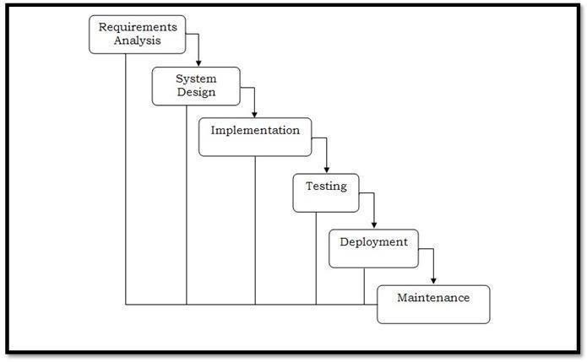

FEASIBILITY STUDY

Feasibility of a project determines whether it is possible to develop the project. These are four main factors, which determine the feasibility of the project. They are discussed follow.

Technical Feasibility Study :-

The main aim of technical feasibility study is to determine whether it is possible to develop the proposed system with the present technologies available and study the technical equipment availability in market.
Feasibility studies are important for projects that represent significant investments for your business. Projects that also have a large potential impact on your presence in the market may also require a feasibility study.
So, in this project technical requirement is:

Hardware: A computer with: -

- Intel Core Processor
- 4GB RAM
- SSD

Software: A computer with: -

- Visual Studio Editor/ Code

Economical Feasibility Study :-

The economic feasibly takes into consideration the financial matters regarding the purposed system. The organization measures the cost effectiveness of the proposed system; the economic feasibility of the proposed system is as under budget of a company or not! This is checked in economic feasibility.
The economic feasibility analysis is a study that will compare the returns to be obtained with the investment required to point out its feasibility, being, therefore, an extremely important process, which brings business intelligence, avoids losses, and leads to more assertive decisions.
As the requirement there is must be the cost of the following things.

Development cost : 9000/- Light Bill : 2000/-
Other : 4000/-

Operational Feasibility Study: -

The operational feasibility deals with the matter whether the proposed system fulfils the requirement of organization. This feasibility determines whether the proposed system covers all the aspects of current system & gives an extra facility which is not in current system.
As the requirement there is no any old system or this system can be used by any computer basic knowledge person.

So, it is also feasible. Operational feasibility is the measure of how well a proposed system solves the problems, and takes advantage of the opportunities identified during scope definition and how it satisfies the requirements identified in the requirements analysis phase of system development.
A project feasibility study is a comprehensive report that examines in detail the five frames of analysis of a given project. It also takes into consideration its four Ps, its risks and POVs, and its constraints. The goal is to determine whether the project should go ahead, be redesigned, or else abandoned altogether. The five frames of analysis are: The frame of definition; the frame of contextual risks; the frame of potentiality; the parametric frame; the frame of dominant and contingency strategies.
- The proposed system will fulfill the organization’s requirements.

- The proposed system covers all aspects of the working current manual system.
- The human sources required for proposed system.

- Staff is totally operational.

- Easy to manage with organization

REQUIREMENT GATHERING

What does your business actually do?
  - Our business provides services for Courses Grocery

What do you want to create a software or website?

  - I want create a website

Do you have any running software?
  - No

What kind of features do you need in your software?

  - I want features like Add Dry item’s, Add item, Delete item Delete item’s,
Update item, Update Items, See your data.

In contact page do you need your office map location?
  - No

Do you need online payment system?

  - No

Do you have any registered domain or hosting?
  - No

This website will cast approx. 15,000/- it is affordable?
  - YES

REQUIREMENT ANALYSIS
Requirement gathering phase of software development life cycle acquires information from the organization for which we are preparing project. There are many techniques to acquire information. It’s simple meaning to get a user’s requirement for website which kind of facility user wants.
Following are the techniques for information gathering.

    - Questionnaire

    - Observation

    - Personal Interview

    - Record Review

From the above options, I have used “Ouestionnaire” method for requirement gathering. I have adopted Questionnaires because I can properly understand their need of website. I can also understand about different rights given to different users and the basic about website. By using Personal Interview I have understood the smallest need of their application and some idea of layout and designing
The main requirements for the site are listed below:

- All users can sign in to Websites.

- Admin can add new websites, Category, Product, and reply websites.

- Only Admin -an delete websites.

- Only Admin can perform User Management.

- Administrator can delete user and also can change rights of user.

- General User can visit and reply website but it is checked by Admin.

- User’s sent website history can be viewed.

- People who are not Users of SHREEJI GROCERY Websites can also see websites.
- New user can also create his/her profile in SHREEJI GROCERY Websites.

PROJECT ABSTRACTS

User Groups:

Administrator

User (Registered Customer)

Administrator:-

    - Admin have full control and management of the website.

    - Add,Delete or Update Grocery item’s from the catalog.

    - Manage Grocery item’s and Courses.

    - Monitor and manage user accounts.

    - Handle customer inquiries and issues.

    - Update website content and policies.

User:-

    - viewer can see Grocery item and Other item’s

    - viewer can download the Grocery item’s pdf.

PROPOSED SYSTEM

Role of the website:

Actual role of this website is to provide the glue between General User and Administrator in the way of:
    - User Management

    - Replying Websites

    - Maintaining Personal Information

Website has been developed with a Front end tool as Google Chrome (A Web Browser) and Visual studio Editor/Coe for Software Developers (Editor and Web Server).
Collaborate with PHP Development Server and Tomcat Server is on the Local machine providing Local Intranet merging three important components for this Website Development namely as under:
    - PHP Development Server (A Web Server)

    - PHP

    - SQL Server

Using of above all is acceptable factors for the real implementation of Website. Because in the there are much number of advantage and simplicity and also security in the point of view for this Web development task. And in the Real Life Application of this type of task above mentioned component had proved as better solution in past and present too.

ADVANTAGES & LIMITATIONS OF PROPOSED SYSTEM

Special Features:

    - Responsive web content for all devise like desktop, laptop, mobile, tablet etc.
    - Additional features of pop up menu when user clicks on specific course.
    - Usersearch the Syllabus and course easy to find.

Disadvantages:
    - Payment method is not including.

PERTCHART AND GANTT CHART

PERT CHART:
PERT (Project Evaluation and Review Technique) charts consist of a network of boxes and arrows. The boxes represent activities and the arrows represent task dependencies. PERT charts are a more sophisticated form of activity chart. Where instead of making a single estimate for each task, pessimistic, likely and optimistic estimates are made. The boxes of PERT charts are usually annotated with the pessimistic, likely, and optimistic estimates for every task. There are thus not one but many critical paths, depending on the permutations of the estimates for each task. This makes analysis of critical path show by using shaded boxes. The PERT chart representation of the MIS problem of show follows.

Design
Hardware
Release
Prototype
Release
Hardware
15 Julay -25 Julay
25 julay -29 Julay
18 S e p t
Create
Specificatio
Test Hardware
END
n
03 Sept
3 Sept -15 Sept
15 S e p t -18 Sept
White
toturiols
Copy -Edit
tutorial
Publish
tutorial
Date

Gantt chart can be derived automatically from PERT charts. However, PERT charts cannot be automatically derived from Gantt charts because PERT charts incorporate additional information about the time when an engineer doses
a task.

This information is not available is helpful in planning the utilization of resources, while the PERT charts is more useful for monitoring the timely progress of activities. Also, parallel activities in a project can be easily identified using a PERT chart.

GANTT CHART

Gantt charts are mainly use of scheduling, budgeting, and resource planning. It allocates resource to activity include Staff, Hardware, Software, etc…
A Gantt chart is a special type of bar chart where each bar represents an activity. The bars are drawn along a time line. The length of each bar is proportional to the duration of time planned for the corresponding activity.

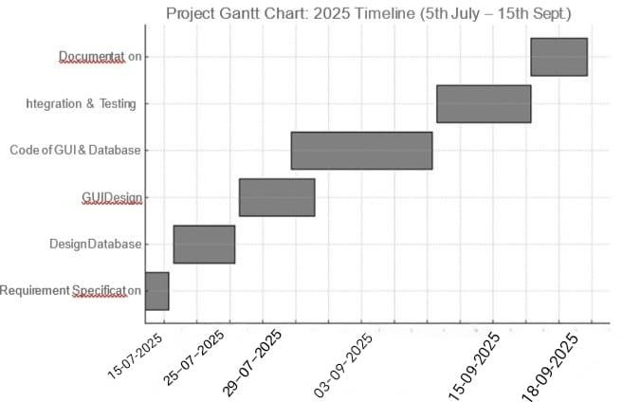

Gantt charts used in software project management are actually an enhanced version of the software project management. Each bar consists of a white part and a shaded part. The white part of the bar shows the length of time each task is estimated to take. The shaded part of the bar shows the slack time.

In order to estimate the time durations for various activities, usually managers let the engineers themselves estimate the time for an activity they might be assigned to.
However, some managers prefer to estimate the time for various activities themselves. Many managers believe that an aggressive schedule motivates the engineers to do a job better and faster.

However, careful aspects, but also cause schedule compromise on intangible quality aspects, but also use schedule delays. A good way to achieve accuracy without creating problems is to let people set their own schedules.
We can see that one engineer can do the database design and then code the database design whereas another engineer and design the GUI part, code the GUI part, and still have time left for writing the user manual. Thus, Gantt charts are very useful in scheduling resources.
So here, I have to follow the scheduling steps for my project.

Gantt chart is really useful us for planning software application resources.

DATA FLOW DIAGRAM

Detailed Life Cycle of Project:
In the discussion of “Detailed Life Cycle of Project” we have to concentrate on DFD (Data Flow Diagram). Here we have work on it while developing this software project.

DFD (Data Flow Diagram):
DFD is a graphical view of all system processes and transactions. With the DFD an End-User also can easily understand the system in a short time period. Also it is useful to find out problems or any complications with the system we are going to develop. We can easily get that whether we have understood the system as per the requirements of the customer or not by showing them this diagram. Thus DFD is a necessary phase while developing software.
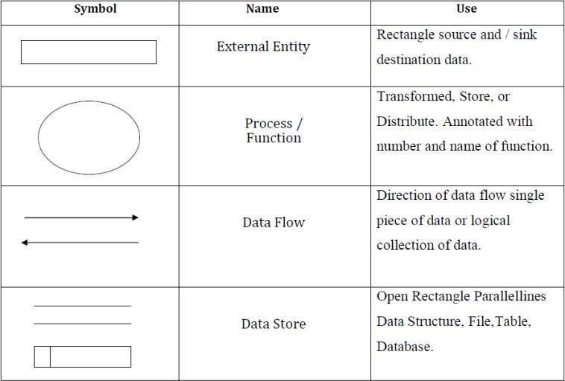

Context Level Diagram :

SHREEJI
GROCERY
Viewer
Admin
User

1st Level Diagram :
User &Admin 1st Level Diagram:
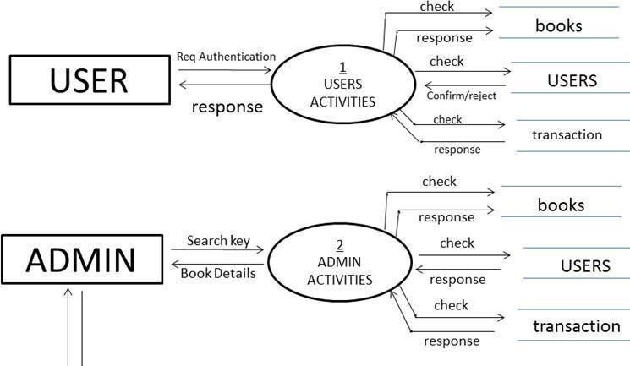
Grocery
Item’s
USERS
Item’s
USERS
Grocery

2st Level Diagram :

User 2st Level Diagram:
login
Login
Check for Login
Respo
Reply
Request
for Item’s
Response
Select
Grocery
Iteam’s
Insert Data

View data
Request for
Item’s
Respons

Select
Insert Data
Item’s
View Data
View Item’s
View
Item’s
Insert Data
Response
View Data
User

Register

Grocery’s

Grocery’s

Grocery’s

Admin 2st Level Diagram:
login
Login
Check for Login
Respo
Reply
Response
Manage
Grocery
Item’s
Insert Data

View data
View, Delete
Respons
Manage
Grocery
Item’s
Insert Data
View Data

View, Delete Response
View
Grocery
Item’s
Insert Data
View Data
Admin
View,
Delete

User-Admin

Grocery’s

‘

Item’s

Grocery Item’s

USE CASE DIAGRAM

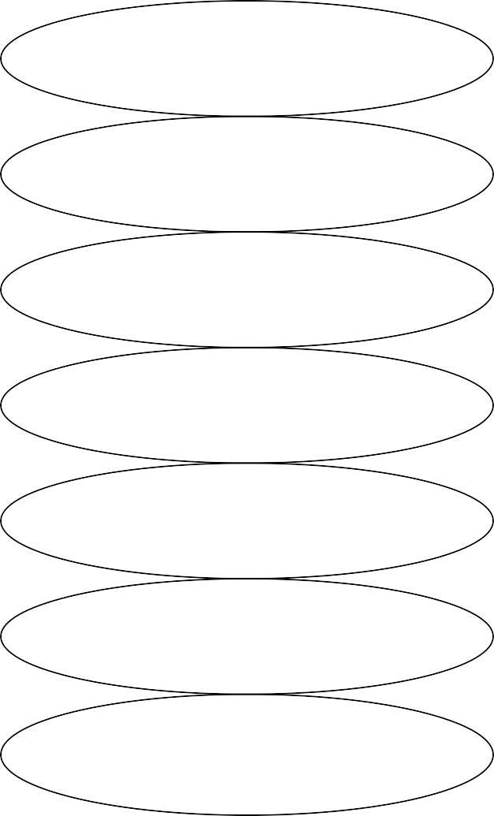
User
Admin
Viewer
Manage User

Add Courses Manage User Data Fill Contact Us Form
Manage Checkout Data

Login Data Remove Courses View Courses
Modify Courses Data

A use case is a set of scenarios that describing an interaction between a user and a system. A use case diagram the relationship among actors and use cases. The two main components of a use case diagram are use cases and actors.

Actor Use case
An actors is represents a user or another system that will interact with the system you are modeling. A use case is an external view of the system that represents some action the user might perform in order to complete a task.
Actor and use case description show the details description of interaction between the actor.
An their use case the description enables have a proper under standing of how actor interact.

FLOW CHART
A Flow is a pictorial representation of an algorithm. Programmers often use it as a program-planning tool for visually organizing a sequence of steps necessary to solve a problem using computer. It uses boxes of different shapes to denote different type of instructions. The actual instructions are written within these boxes using clear and concise statements. Solid lines having arrow marks connect these boxes to indicate the flow of operation, that is, the exact sequence in which to execute the instructions. The process of drawing a flowchart for an algorithm is known as flowcharting.

Basic Flowchart Symbols:

Terminal

Processing
Input / Output

Decision

Flow Lines Connectors

User Login Flowchart:

Start

login Admin

Login

View
Iteam’s
Ragister

NO

Login

Yes

No

Add Grocery ‘s

Category Product

Add admin

View contect

confirm order

yes

Update
Grocery’s

Update
Grocery’s

Logout
View And Delete Groceri’s

End

End

COST ESTIMATION
Working time estimation is as given,
3 months = 25 days / month = 75 days 3 hr / day = 215 hours
Now, the expenses & cost estimation are given below: Computer rent = 6000 /-
+ Light Bill Rs. 5 / unit
Worth 400 units = 2000 /-
+ Database design & creation = 3500 /-
+ Coding & Validation = 2500 /-
+ Extra Exp. = 1000/- Total = 15000/-
Thus the approximation cost of this Web Site Project will be about Rs
25000/-.

DATA DICTIONARY & NORMALIZATION
Database Name: GROCERY
Table 1: tbl_admin

Column Name | DataType (Size) | Constraints | Remarks
Id | Int(10) | A.I, P.K,NN
Username | Varchar(30) | NN
Password | Varchar(30) | NN

Table 2: add_cart

Column Name | DataType (Size) | Constraints | Remarks
Id | Int(11) | A.I, P.K,NN
Name | Varchar(50) | NN
Image | Text | NN
Price | Varchar(30) | NN
User_Id | Int(150) | NN

Table 3: tbl product

Column Name | DataType (Size) | Constraints | Remarks
Id | Int(11) | A.I, P.K,NN
Name | Varchar(30) | NN
Category | Varchar(30) | NN
price | Int(11) | NN
Image | text | NN

Table 4: tbl_ordernow

Column Name | DataType (Size) | Constraints | Remarks
Id | Int(20) | A.I, P.K,NN
Name | Varchar(150) | NN
Image | Varchar(250) | NN
Quentity | Int(20) | NN
Total | Int(100) | NN
Pay_Method | Varchar(100) | NN
Address | Varchar(100) | NN
Mobile | Varchar(100) | NN
User_id | Int(100) | NN

Table 5: tbl register

Column Name | DataType (Size) | Constraints | Remarks
Id | Int(11) | A.I, P.K,NN
Full Name | Varchar(30) | NN
Email | Varchar(30) | NN
Password | Varchar(30) | NN

Table 6: tbl reviews

Column Name | DataType (Size) | Constraints | Remarks
Id | Int(11) | A.I, P.K,NN
Name | Varchar(30) | NN
Email | Varchar(30) | NN
Message | text | NN

SCREEN LAYOUTS
Index.php
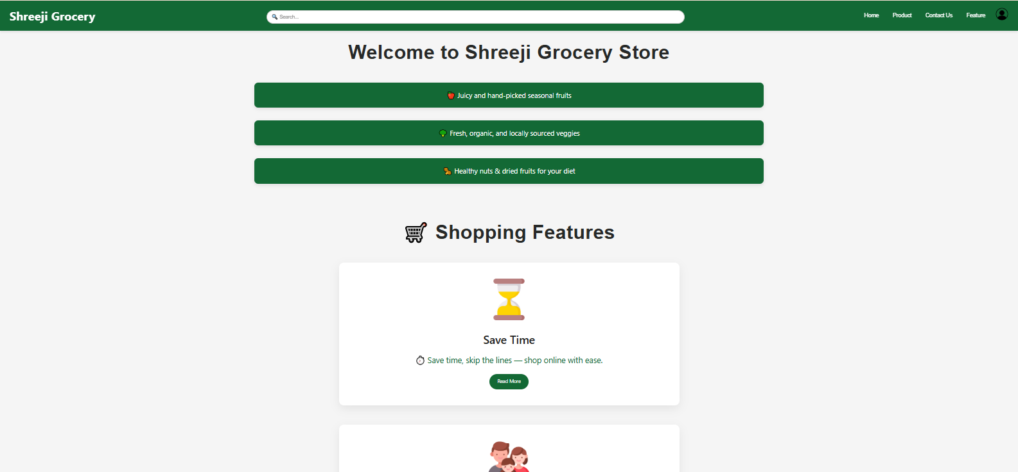
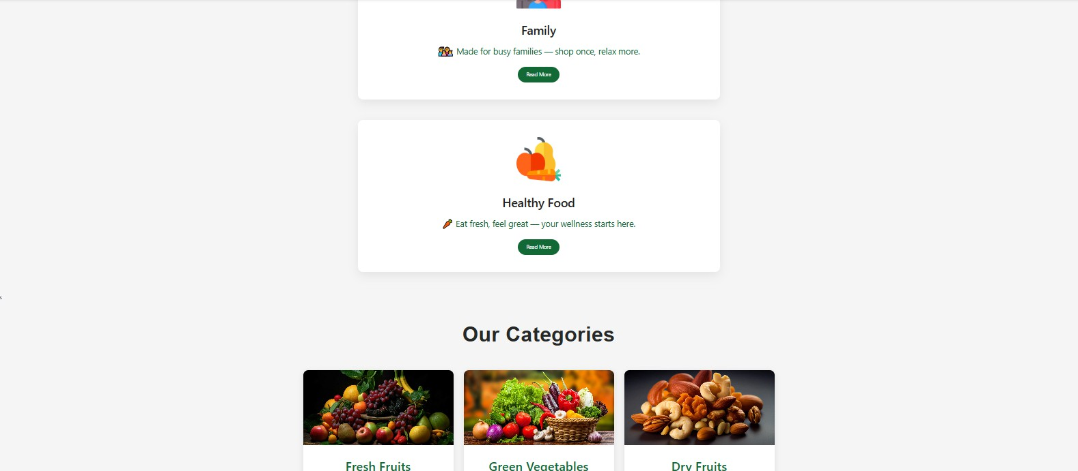

Product.php

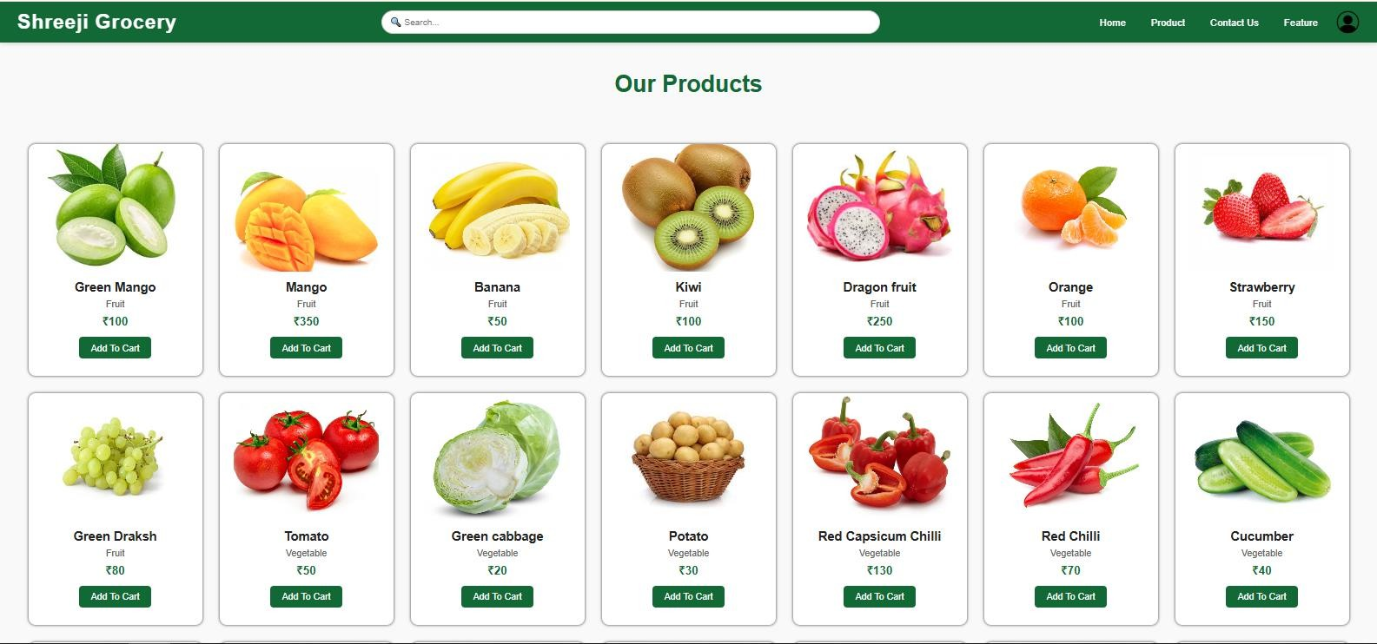

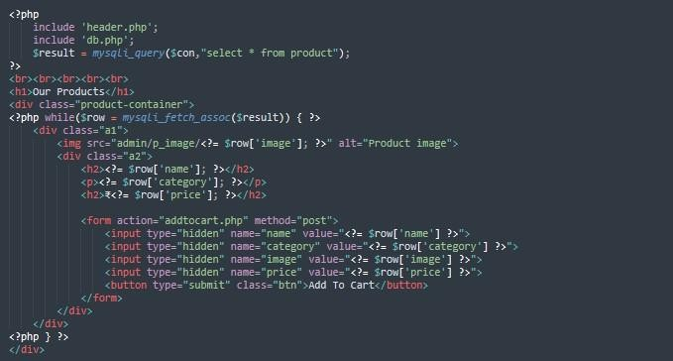

Order.php

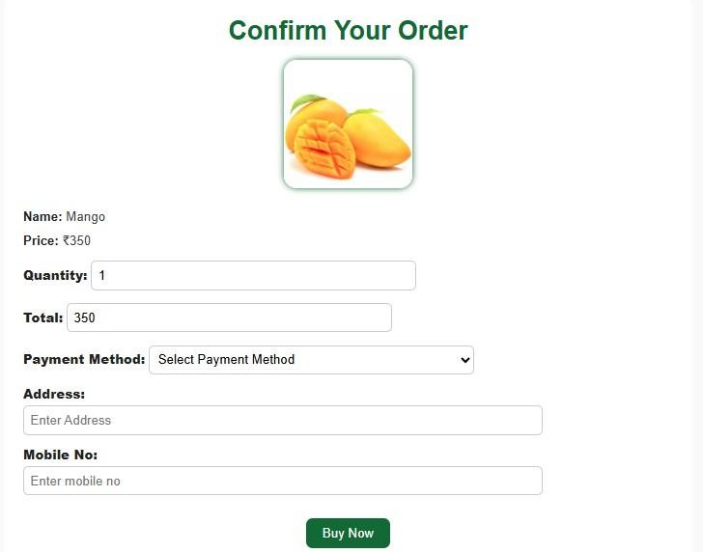
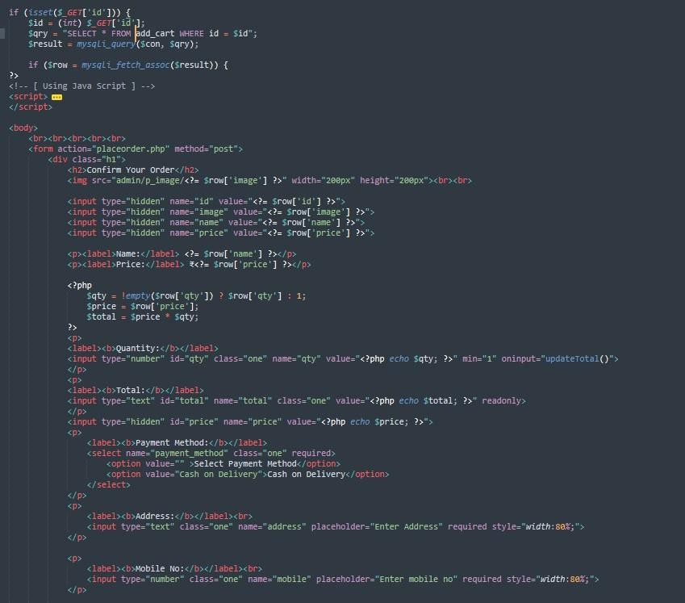

Feedback.php
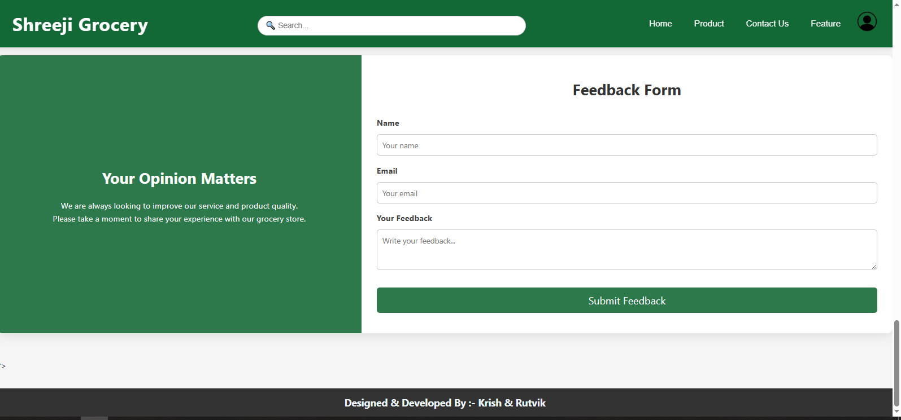

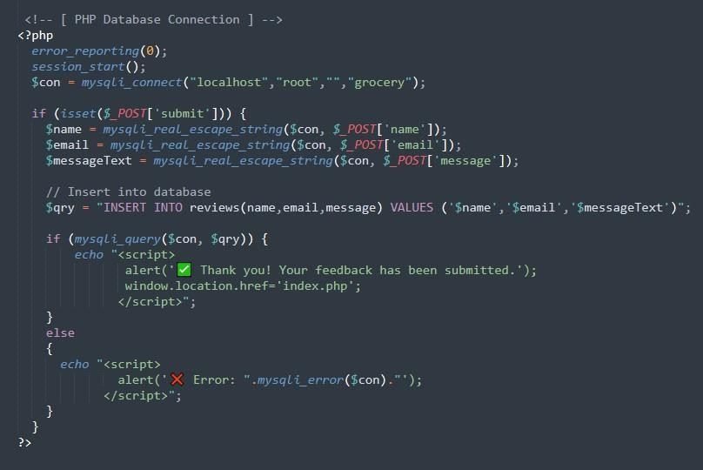

Admin_login.php
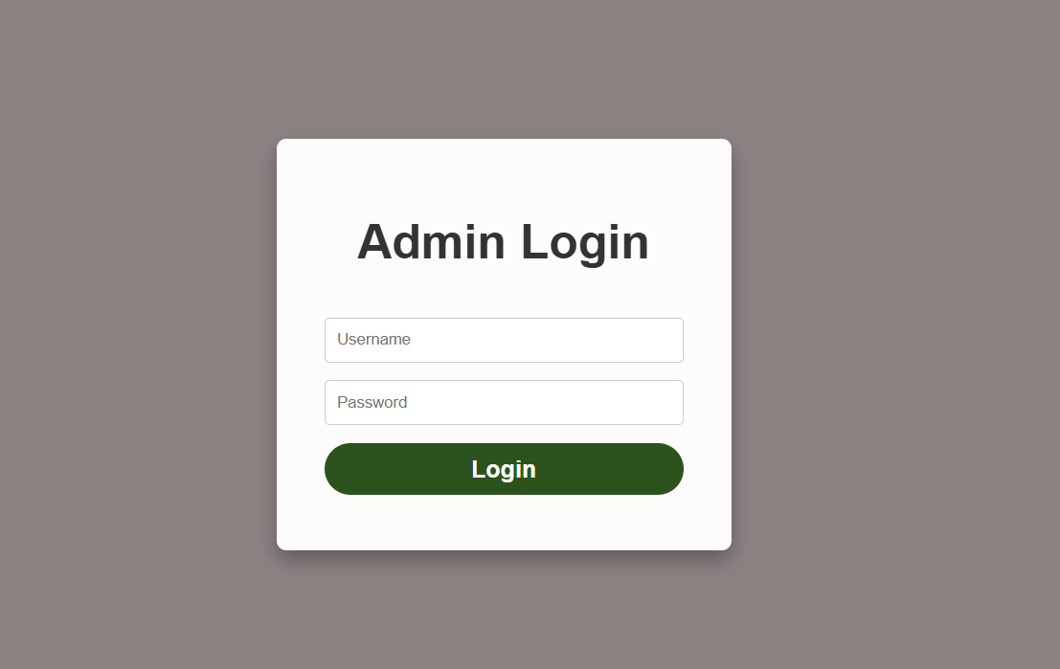

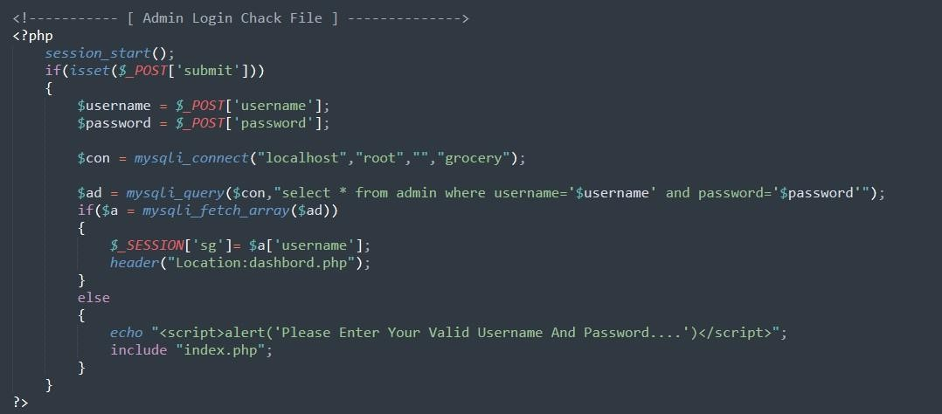

Category.php
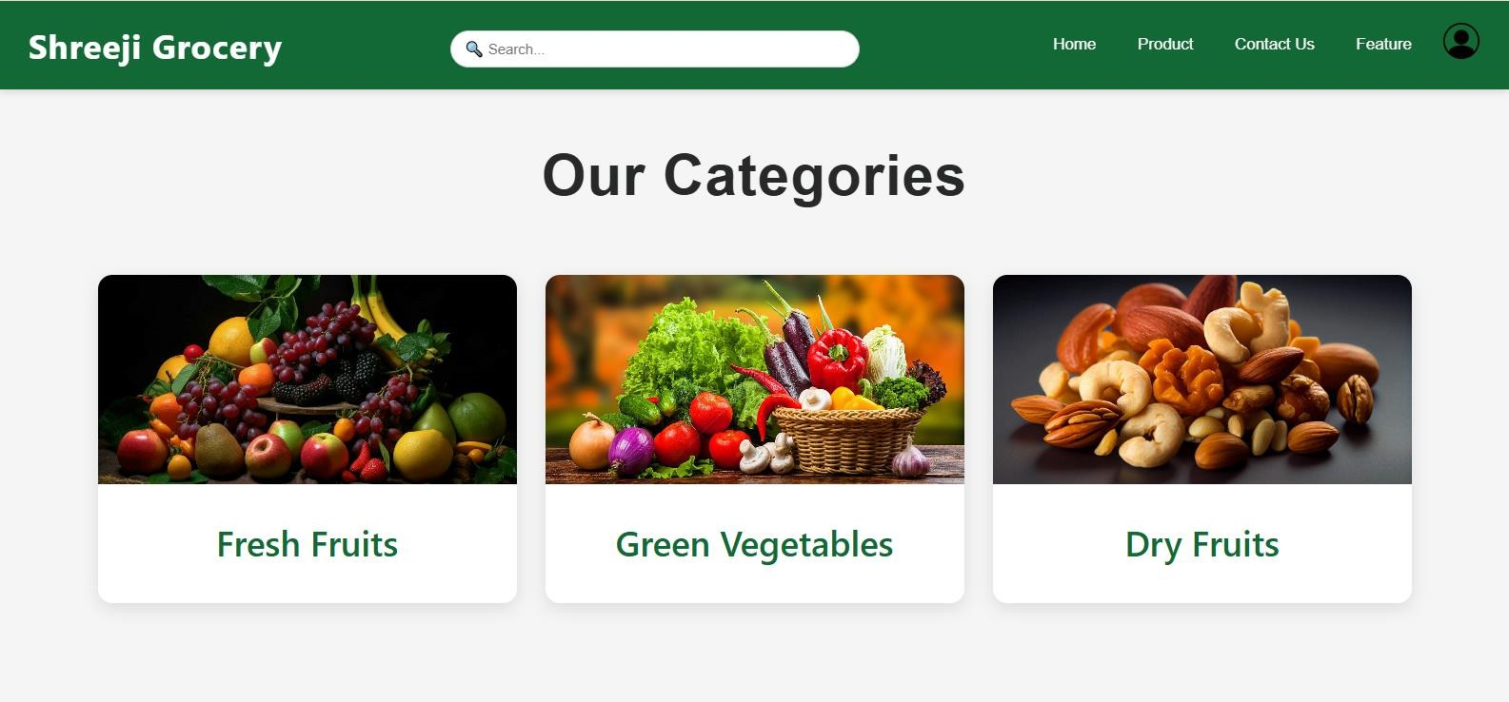
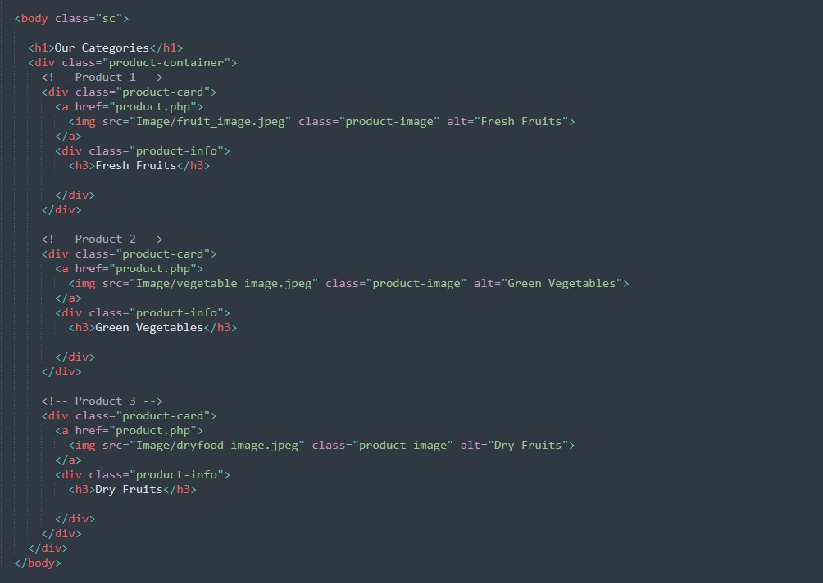

SHREEJI GROCERY BSC IT 5th SEMESTER S.S.S.D.I.I.T College

Contact.php
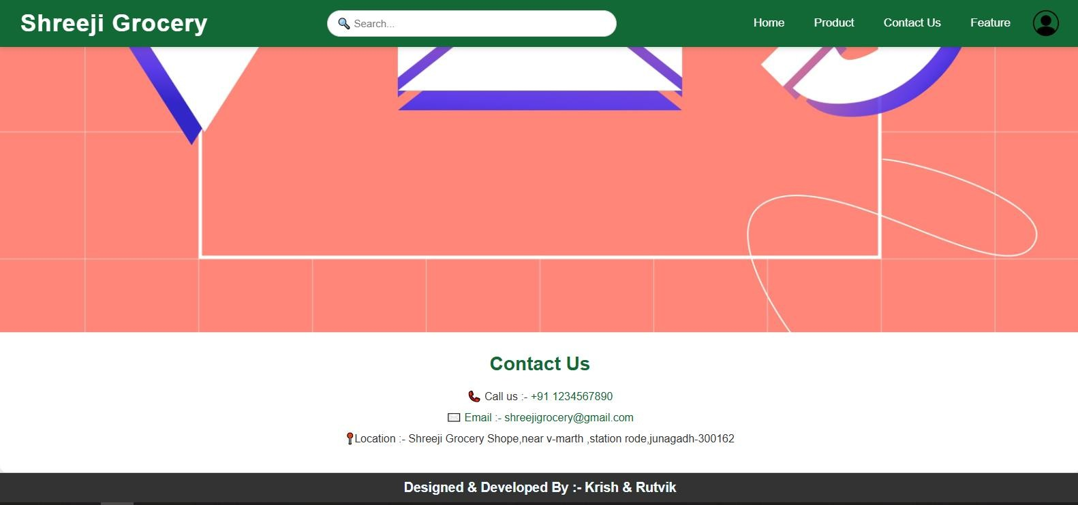

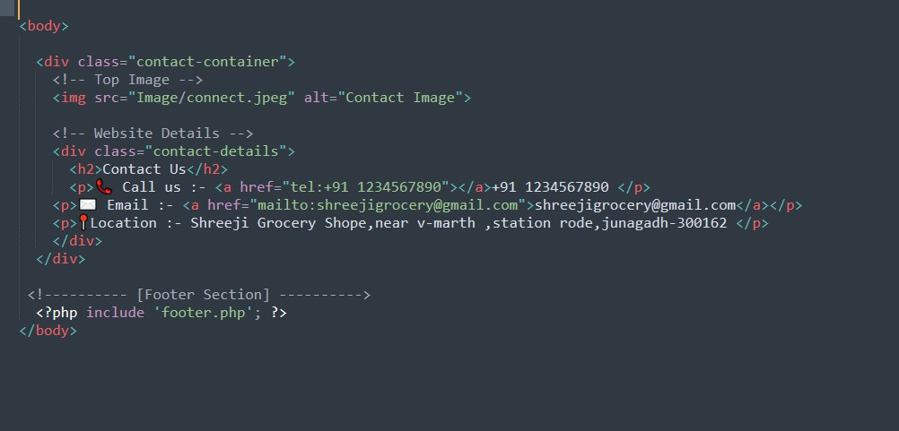

SHREEJI GROCERY BSC IT 5th SEMESTER S.S.S.D.I.I.T College

SPECIAL UTILITIES

Following are special utilities provided by Shreeji Grocery

- Attractive layout provides to user.
- Easy to Add Product.
- Easy to Show Product Details.
- To Admin can Edit & Delete Items.

TESTING

Software Development Life Cycle (SDLC) includes a series of production activities one of this is testing.
Testing is a process of executing a program with the intent of finding an
error.

Testing is the most important element to be considered for providing quality software and it represents the ultimate review of specification, design and coding.
The success or failure of the software as a system mainly depends on testing. Software developer spends 40% to 50% of their total development time on testing.
There are several SDLC techniques and development mode. I have focused on Waterfall Model. I have followed the Waterfall model to develop this software.
The development of software system involves a series of production activities where opportunities for injection of human fallibility are enormous. Error may begin to occur the very inception of the process where the objectives may be erroneously or imperfectly specifies, as well as later design and development states. Because of human inability to perform and communicate with perfection, software development is accompanied by a quality assurance activity.
Testing is program consists of providing the program with a set of test inputs and observing if the programs behave as expected. Under which a failure

occurs are noted for debugging and correction. The following are some commonly used term associated with testing.
A failure is manifestation of an error. But, the presence of an error may not necessarily lead to a failure.
A fault is an incorrect intermediate state that may have been entered during program execution. A fault may or may not lead to a failure.
A test case is the triplet [I.S.O.], where I am the data input to the system, S is the state of the system at which the data is input, and O is the expected output of the system.
A test suite is the set of all test cases of all test cases with which a given software product is to be tested.
Many types of testing techniques are describing as follows.

Unit Testing:

Unit testing is under taken when a module has been coded and successfully reviewed in this section we first discuss the environment needed to perform unit testing.
Here in this project we test each and every module and forms of software application individually when it is completely code.
There are some methods for unit testing are as follows.

Black-Box Testing:

- Equivalence Class Partitioning
- Boundary Value Analysis

White-Box Testing:

- Statement coverage
- Branch coverage
- Condition coverage
- Path coverage
- Linearly independent path
- Data flow based testing
- Mutation testing

Integration Testing:

The primary objectives of the integration testing is to test the module interface in order to ensure that there are no error in parameter passing when one module invokes another module.
During integration testing different module of system as per integration plane the integration plan specify the steps and the order in which module are combine to realize the full system.
After each integration test the practical integrated system is tested. Following are the integration testing methods & approaches.
  - Big bang approach
  - Top down approach
  - Bottom up approach
  - Mixed approach

System Testing:

In the system testing the whole application is tested and the error and failure possibility is carried out in it.
Following are the method & approach of system testing.

- Alpha testing
- Beta testing
- Acceptance testing
- Performance testing
- Error seeding

Testing is a process of executing a program with the intent of finding an
error.

A good test case is one that as a high probability of finding an as yet in discovered error.
A successful test is one that uncovers a yet undiscovered error.

Software testing is a critical element of software quality assurance and represents the ultimate review of specification, design and coding the increasing visibility of software as a system element and the attendant “Cost” associated with a software failure are motivating forces for well-planned, through testing. It is not unusual for a software development organization to expend between 30 to 40 percent of total project effort on testing. In the extreme, testing of human rated software can cost three to five times as much as all other software engineering activities combined.

Testcase of Login form:

No | Test Case | Description | Prerequisites | Input data | Expecte d Result | Actul Result | Pass/fail
1 | username | To check that Username field can’t be blank | Internet  should have be not availa ble | - | Should not blank the  username | Should not blank the  username | Pass
2 | Password | To check that user enter  Minimum 12 character. | Internet  should have be not available | - | User enter character and digit. | User enter character and digit. | Pass

VALIDATION CHECKS TEST CASES:

A Test case is a set of conditions or variable under which a tester will determine whether a system satisfy requirement or works correctly.
The process of developing test case can also help to find the problem in requirement or design of an application.
A test case can have the following elements, not however that normally a test management tool is used by companies by the tool used.
Test Suit ID: The ID of the test suit, to which this test case belongs.

Test Case ID: The ID of the test case.

Expected Result: The expected result of the test. Actual Result: The actual result of the test, to filled after executing the test case.
Created By: Krish Savaliya And Rutvik Sorathiya.
Executed By: Krish Savaliya And Rutvik Sorathiya.

Pass/Fail: The result in "Pass" or "Fail" according to the test, when the expected result and the actual result is same then the result is "pass" else result is "fail".

Remark: Any comment on the test case or test execution.

I create following some test cases which is executed by me.

IMPLEMENTATION

Implementation refers to the entire effort associated with a new system. The implementation of a web application involves longer term issues after the system has been designed and installed. Implementation is a part of the design of a web application, and is an organizational change process. It is a part of the process that begins with the very first idea for a web application has been successfully integrated with the operations of the organization. We expect most of the implementation to be concerned with behavioral phenomena since people are expected to change their information processing activities.
The implementation is processed from review and reports from developer cover following areas:
- Good working conditions.
- Use full for gathering information.
- Update website easily.
- Attractive layouts.
- Working for as per requirements.

BIBLIOGRAPHY

Websites used:

- https://www.w3schools.com

- https://www.geeksforgeeks.com

- https://www.youtube.com

